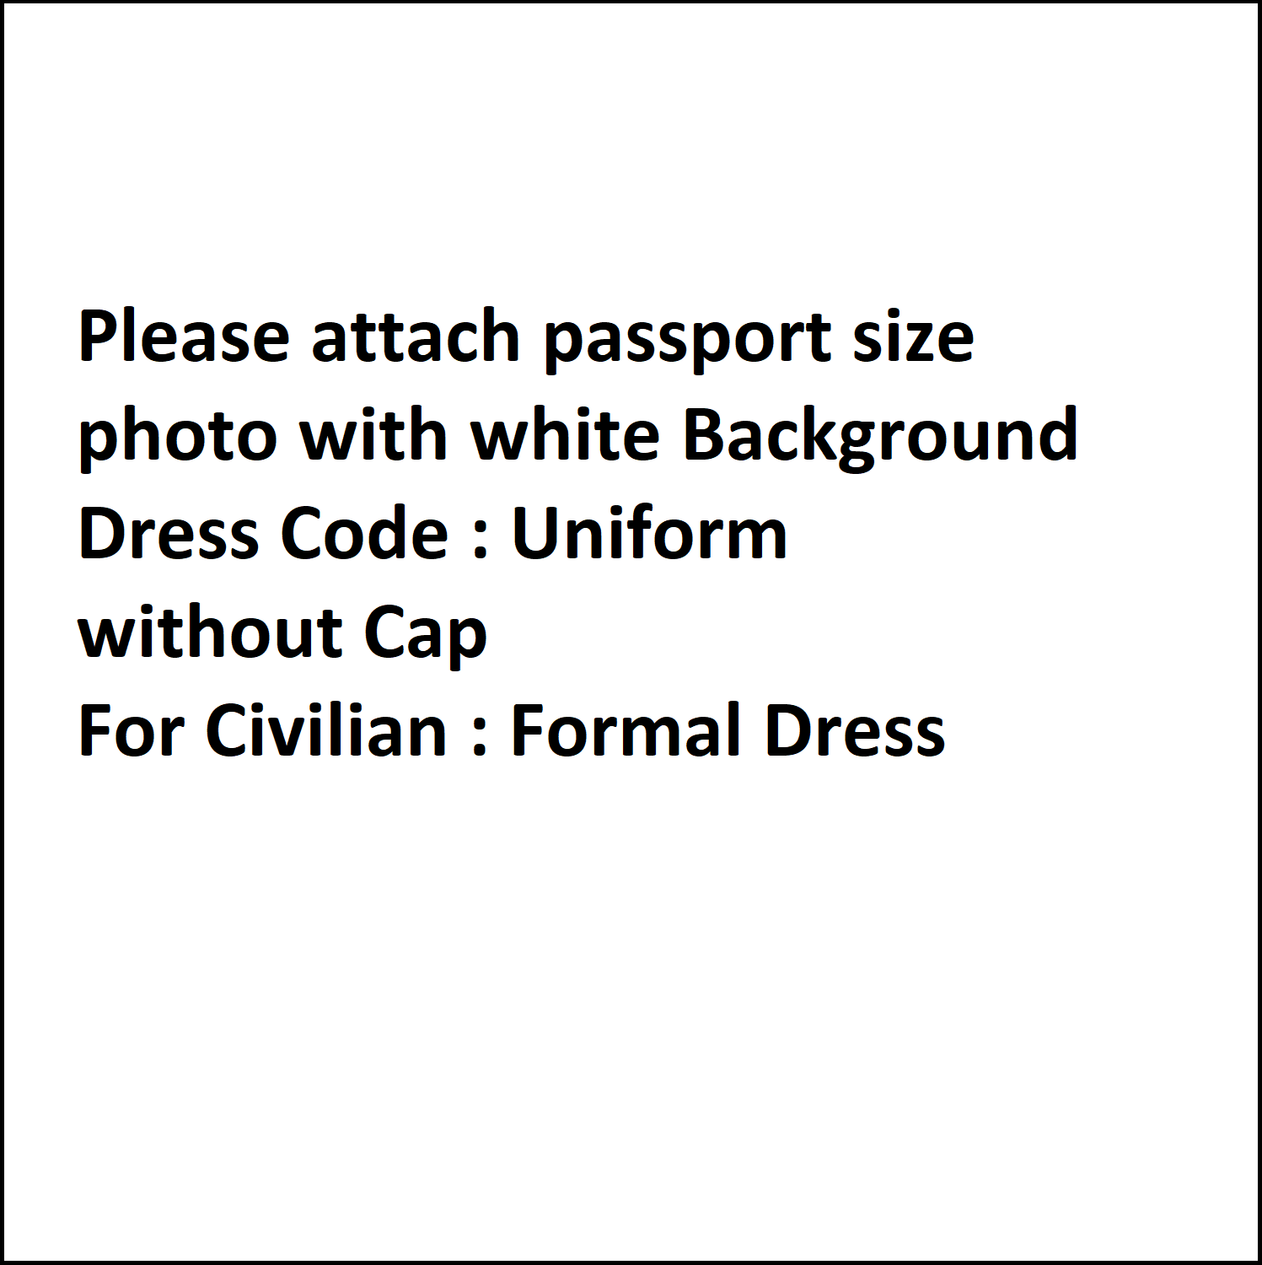
DEPARTMENTAL WELFARE NO.
WOMEN’S WELFARE NO.

MALE | FEMALE | OTHERS

BANGLADESH FIRE SERVICE & CIVIL DEFENCE KAZI ALAUDDIN ROAD, DHAKA-1000
EMPLOYEE INFORMATION

PLEASE FILL UP IN ENGLISH CAPITAL LETTERS
(1 copy of passport size pic of Employee & all nominees)
FULL NAME
FATHER’S NAME
MOTHER’S NAME
OLD PIN |  | NEW PIN
RELIGION
BLOOD GROUP
BATCH NO.
ID CARD NO.
GPF NUMBER
PASSPORT NO.
NID NO.
GENDER
(Tick the empty box)
DATE OF BIRTH
DATE OF JOIN
DISTRICT OF BIRTH
NATIONALITY
DISABILITY CODE

ETHNIC MINORITY
DISABLED
FREEDOM FIGHTER
GENERAL
ORPHAN
POSHSHO

SINGLE
MARRIED
SEPARATE

PERSONAL MOBILE NO:
MOBILE NO. (HOME)

TIN NUMBER
QUOTA
(Tick the empty box)
MARITAL STATUS
(Tick the empty box)
SPOUSE INFORMATION
 |  |  | NAME
 |  |  | TIN NO
PROFESSION
(Tick the empty box)
 |  |  |  |  | GOVT. |  | OTHER’S
 |  |  | HOME DISTRICT
 |  |  | TOTAL CHILD
EMAIL NO.

PRESENT ADDRESS

EMERGENCY CONTACT

BODY DETAILS

Height (inch.)
Weight (Kg.)
Identiﬁcation (according to Service Book)

NAME
MOBILE
RELATIONSHIP

DIVISION
DISTRICT
UPAZILA
POST OFFICE
POSTAL CODE
VILLAGE/ROAD/AREA
UNION/CITY CORPORATION WARD
HOUSE/HOLDING NO

DIVISION
DISTRICT
UPAZILA
POST OFFICE
POSTAL CODE
VILLAGE/ROAD/AREA
UNION/CITY CORPORATION WARD
HOUSE/HOLDING NO

DESIGNATION
GRADE
OFFICE / STATION NAME
ATTACHMENT INFORMATION
OFFICE DIVISION
OFFICE DISTRICT
OFFICE UPAZILA / THANA

PERMANENT ADDRESS
JOB ASSIGN (CURRENT JOB INFORMATION )

EXAMINATION  (Tick the empty box) | EIGHT PASS/JSC/JDC  S.S.C  DAKHIL  S.S.C VOCATIONAL  O LEVEL/CAMBRIDGE  S.S.C EQUIVALENT  Group/Subject:  Humanities Business Science
BOARD
BOARD ROLL
RESULT
PASSING YEAR
SCHOOL / COLLEGE

EDUCATIONAL QUALIFICATION

Group/Subject:
Humanities | Business | Science

H.S.C
ALIM
BUSINESS MANAGEMENT
DIPLOMA ENGINEERING
A LEVEL/SR. CAMBRIDGE
H.S.C EQUIVALENT
DIPLOMA IN PHARMACY

EXAMINATION
(Tick the empty box)

EDUCATIONAL QUALIFICATION
BOARD
BOARD ROLL
RESULT
SUBJECT/DEGREE
PASSING YEAR
SCHOOL / COLLEGE

EXAMINATION  (Tick the empty box) | B.A  B.S.S  B.S.C  B.COM  BBA  L.L.B  FAZIL  HONORS EQUIVALENT  OTHERS
COURSE DURATION
RESULT
SUBJECT/DEGREE
PASSING YEAR
COLLEGE/UNIVERSITY

EDUCATIONAL QUALIFICATION | EXAMINATION (Tick the empty box) M.A M.S.S M.SC M.COM MBA L.L.M M.PHIL KAMIL MASTERS EQUIVALENT OTHERS  COURSE DURATION  RESULT  SUBJECT/DEGREE  PASSING YEAR  COLLEGE/UNIVERSITY  - If you have any other educational qualification then add them in the below field.  Professional/Other Experiences:  Designation/ Post Organization Name Responsibilities From To

Journal/Publications

NOMINEE INFORMATION | NOMINEE NAME  RELATIONSHIP  NID/BIRTH CERTIFICATE  PERCENTAGE (%)  PERMANENT ADDRESS  NOMINEE NAME  RELATIONSHIP  NID/BIRTH CERTIFICATE  PERCENTAGE (%)  PERMANENT ADDRESS

Title
Publication/Publisher
Publication Date
Author
Publication URL

Promotion & Posting: First Joining to End & Attachment Information shall be included (To be filled up by office according to Service Book)
Designation | Grade | Office/Station | From date | To date | Remark

Punishment (To be filled up by office according to Service Book)
Punishment Name | Offence | From date | End Date | Action | Punishment  Sanction Authority, Memo No. & Date

Award (To be filled up by office according to Service Book)
Name of Award | Field of Award Achievement | Issue Authorities | Memo  No & Date | Remark

Leave (To be filled up by office according to Service Book)
Type of Leave | From date | To date | Memo & Date

Abroad (বৈদেশিক) Training (To be filled up by person)
Course Name | From date | To date | Venue & Country | Memo No & Date | Result

Inland (অভ্যন্তরীণ) Training (To be filled up by person)
Course Name | From date | To date | Venue & Country | Memo No & Date | Result

Inhouse (বিভাগীয়) Training (To be filled up by person)
Course Name | From date | To date | Venue & Country | Memo No & Date | Result

(Employee Signature) | (Authority Signature)

